Version

1

By: vijay garothaya

Java 11 Installation Guide

Table of Contents

* Download Java 2
* Install Java on Mac 5
* Installation Verification 9

# Download Java

Goto URL : <https://www.oracle.com/java/technologies/javase-downloads.html>

Scroll to section: “Java SE 11 (LTS)” as shown below:

Click on JDK Download.

Click on “jdk-11.0.7_osx-x64_bin.dmg” to download.

Accept Agreement and click on “Download jdk-11.0.7_osx-x64_bin.dmg”.

Sign-in with oracle account. If you don’t have one already, you can register free using link “Create Account”

File after download.

# Install Java on Mac

Double click the dmg file to install Java.

Double click JDK 11.0.7.pkg file.

Click on continue.

Click on Install

Installation required administrator permission. Enter Mac Administrator Username and password and click “Install Softwre”

Installation in progress…

Installation complete

Move the dmg package file to trash by clicking “Move to Trash”.

# Installation Verification

Open the terminal window.

Option 1: To open terminal window

Click “command + space bar” and type terminal and click enter

Option 2: To open terminal window

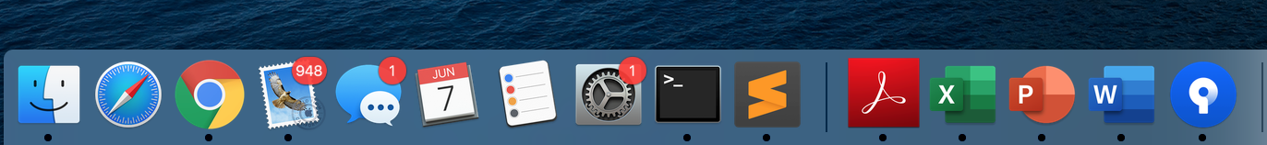

Type “java -version” on terminal as shown:

Click enter to see the result. Result should show “java version "11.0.7" 2020-04-14 LTS” as shown below:

With this we are done with Java 11 installation.